The Town of Bluffton holds a paramount objective to maintain the environment, nature, resources, and air quality within the incorporated boundaries of the town, as well as the health, safety and welfare of its citizens, therefore the Town of Bluffton believed it was appropriate to enact certain regulations relative to open burning within its incorporated boundaries. If a citizen of Bluffton wishes to burn outdoors, they must adhere to the following guidelines. Citizens wishing to burn shall call the Bluffton Township Fire District at (843) 757-8174 the day they intend to burn to determine if burning is allowed and give notification.
EXEMPTIONS:

The provisions of this Ordinance do not apply to Controlled Fires as defined above and referenced in the Notifications/Precautions law (SC Code 48-35-10) and Department of Health and Environmental Control Regulation 61-62.2. Therefore, the controlled burner shall comply with the laws, regulations, and Smoke Management Guidelines aforementioned when conducting such Controlled Burning. The South Carolina Forestry Commission shall be notified of any outdoor Controlled Burning as stated in the aforementioned laws and regulations prior to notifying the Fire Department and before any outdoor Controlled Burning is conducted.

Registration is not required for outdoor fixed and portable barbecues located at public parks and/or public beaches, One- and Two- Family Dwellings and open common areas of Multi-Family Buildings. Also exempted are approved outdoor fireplaces, food smoking units, outdoor cooking stoves and/or grills.

Exempted from this Ordinance are approved outdoor fireplaces/fire-pits, food smoking units, outdoor cooking stoves, and/or grill’s. Approval of these devices shall be performed on an annual basis.

PROHIBITED USE:

(a) Multi-Family Buildings, Apartment Buildings or other buildings not defined as One-and Two-Family Dwellings shall not operate charcoal burners, outdoor fixed and portable barbecues or open-flame devices on combustible balconies or within ten (10) feet of combustible construction.

Exception: Where buildings and decks are protected by an automatic sprinkler system.

(b) Multi-Family Buildings, Apartment Buildings or other buildings shall not store or use LP-gas burners or LP-gas containers with a water capacity greater than two and one-half (2.5) pounds [nominal 1 pound LP-gas capacity] on combustible balconies or within ten (10) feet of combustible construction.

(c) All Commercial Burning is prohibited unless done in conformity with this Ordinance.

REGISTRATION, NOTIFICATION AND PROHIBITIONS:

The approval to burn does not relieve the holder of the responsibility of the damage of adjoining property and shall in no way be construed to hold the Town of Bluffton or the Bluffton Township Fire District responsible for any damage to Persons or property.

(a) Applicants are required to register, obtain a Registration Number, and give notification with the Fire Chief prior to any Open Burning Fire, Ceremonial or Religious, Bonfire, or Residential Burn.

(b) Applicants are required to register and obtain a Registration Number prior to any Recreational Fires, Warming Fires. No advance daily notification to the Fire Chief is required so long as an annual Registration Number has been issued.

(c) Open Burning may only occur between the hours of 9:00 a.m. and sunset, seven days a week. Recreational Fires, Warming Fires, and Ceremonial or Religious Fires shall occur between the hours of 9:00 a.m. and 12:00 midnight. All Open Burning Fires shall be fully extinguished by sunset and all Recreational Fires, Warming Fires, and Ceremonial or Religious Fires shall be fully extinguished by 12:00 midnight. Burning hours may be extended with the approval of the Fire Chief.

(d) Registration shall be applied for in-person Monday through Friday by visiting any of the respective Fire District’s Fire Stations between the hours of 8:00 a.m. and 6:00 p.m. Registration shall be issued on an annual basis, starting January 1 of each year and shall expire the last day of that year. No more than one annual Registration Number shall be issued to a property address.

(e) Any Person, who registers for a Ceremonial, Religious, Bonfire, Open Burning Fire, or a Residential Burn approval, shall call the Fire Department the day he intends to burn to determine if burning is allowed on that day and to request permission to burn. The assigned annual Registration Number shall be required to be logged at the Fire Department each day burning is requested. Failure to log the burn Registration Number with the Fire Department on each occasion and follow any other restrictions as stated in this Ordinance as they pertain may result in a fine and/or the revocation of Registration Number.

(f) The Fire Chief shall have the discretion to prohibit any or all burning (excluding forestry, agriculture, and wildlife burns) in response to drought conditions or when the atmospheric conditions or local circumstances make fires hazardous.

(g) The Fire Chief shall be allowed access to inspect the property relevant to a Registration Number being issued. The Fire Chief is authorized to revoke a Registration Number for any fire that is determined to be a public safety or health hazard.

(h) All Open Burning, Residential Burning, and Commercial Burning requires compliance with the state law if such burning occurs inside corporate limits. The burning of yards, lawns, grown over lots, etc. shall be predetermined by a site visit from the Fire Department, to determine if the burning will be constituted as a burn of such magnitude that shall be referred to the South Carolina Forestry Commission as required by the Notifications/Precautions law (SC Code 48-35-10).

In addition, any burning shall be subject to the following conditions:

1) The Person attending to or performing the Open Burning or Residential Burn shall have an approved Registration Number in his possession at the site. 2) Attendance by a Responsible Person who is capable of controlling the fire, taking emergency action and calling for assistance is required at the site at all times. A phone, cellular or landline shall be available on site.

3) The Person performing the Open Burning or Residential Burn shall maintain a garden hose connected to a water supply where water is available. If water is not available then on site Fire-extinguishing Equipment, approved by the Fire Chief, shall be on hand to control and extinguish the burn/fire.

4) Recreational Fires, Warming Fires and Ceremonial or Religious Fires are restricted to burning Natural Vegetation that originates on the premises, commercially prepared fireplace logs, charcoal, or other non-treated wood, but does not include Rubbish.

5) Open Burning shall not be conducted within fifty (50) feet of any structure or stored combustible material and adequate provisions are to be made to prevent the fire from spreading to within fifty (50) feet of any structure, except that burning shall be allowed if in an Approved Waste Burner located greater than fifteen (15) feet away from any structure or combustible material. Conditions, which could cause a fire to spread to within twenty-five (25) feet of a structure, shall be eliminated prior to ignition.

6) Recreational Fires, Warming Fires, and Ceremonial or Religious Fires shall not be conducted within twenty-five (25) feet of a structure or combustible material unless the fire is contained in an Approved Waste Burner located greater than fifteen (15) feet away from any structure or combustible material. Conditions, which could cause a fire to spread to within twenty-five (25) feet of a structure, shall be eliminated prior to ignition. The Person monitoring the fires listed in this subparagraph shall maintain a hose connected to a water supply. If no water is available, other Fire-extinguishing Equipment must be present.

7) No Open Burning, Recreational Fires, Warming Fires, and Ceremonial or Religious Fires Registration Number shall be issued for a total fuel pile area greater than three (3) feet in diameter and two (2) feet in height.

8) No flammable or combustible liquids shall be used to ignite or maintain Open Burning Fires, Residential Fires, or Bonfires.

9) No Person shall kindle a fire upon the land or property of another without the permission of the owner thereof or his agent.

10) No Open Burning Fires, Recreational Fires or Warming Fires shall be conducted on any beach located within the Town of Bluffton.

11) The Registration Number when granted does not exempt, relieve or excuse the Person responsible for the burning from the consequences of and/or damages or injuries and civil liability resulting from the burning.

12) In the event of a complaint, written or verbal, due to smoke or odor emissions, the Fire Chief may revoke or suspend the Registration Number previously issued, provided the complaint appears reasonable under the circumstances, where at such time the fire shall be required to be extinguished by either the permit holder or the Fire Department.

SPECIAL BURNING REGISTRATION AND NOTIFICATION:

(a) Storm Debris: Debris in the form of Natural Vegetation generated as a result of severe- wind storms, hurricanes, tornadoes, or other natural disasters shall be burned at approved sites in accordance with the Beaufort County’s disaster preparedness plan and with a Registration Number issued by the Fire Chief and authorization from all other appropriate permitting agencies. All man made materials and processed natural materials shall be disposed of in accordance with Federal Environmental Protection Agency and State Department of Health and Environmental Control Regulations.

(b) Bonfires, Ceremonial or Religious Fires: Local schools and community organizations may be issued a special Registration Number to conduct a Bonfire. A Bonfire shall not be conducted within one-hundred (100) feet of a structure or combustible material. Conditions, which could cause a fire to spread to within one-hundred (100) feet of a structure, shall be eliminated prior to ignition. Items that may be burned in a Bonfire are untreated wood/lumber and natural unprocessed forest products. Flammable liquids and/or material shall not be used during the ignition or burning phases of the Bonfire. Bonfire material shall not be assembled more than six (6) hours prior to setting of the fire. A Bonfire shall be no more than six (6) feet high by twelve (12) feet in any ground dimension and shall not burn longer than three (3) hours.
A Bonfire shall not burn later than 12:00 midnight. The Fire Chief may only increase the size and duration when it is determined that the fire safety requirement of the situation and the desirable duration of burn warrant the increase. An on-site inspection of the materials to be burned and the manner in which they are to be assembled is required. Inspections by the Fire Chief are required prior to and during the construction of the Bonfire. At least two (2) Responsible Persons shall be present during the entire time the fire is in progress and until such time as the fire is completely extinguished. At least two 2½ gallon water pressure type fire extinguishers, or their equivalents, shall be present for use at the burn site. No Bonfires may be conducted on any beach located within the Town of Bluffton.

(c) Commercial & Residential Land Clearing: Persons conducting land and lot clearing may be issued a special Registration Number to conduct burning of debris in the form of Natural Vegetation that has grown on the same property being cleared. Debris shall be burned by the use of an enhanced air burner, when required by the State Department of Health and Environmental Control Regulations. When an enhanced air burner is required, the owner or agent shall first obtain written authorization from the South Carolina Department of Environmental Control prior to receiving a Registration Number from the Fire Department. If an enhanced air burner is not required by the South Carolina Department of Environmental Control due to property restrictions, the Fire Chief shall allow Commercial Burning as long as the following restrictions are adhered to: (1) All Commercial Burning shall comply with the regulations set by the South Carolina Department of Health and Environmental Control;

(2) The owner or owner’s agent must call the Fire Department on the day the Commercial Burn is planned to determine if burning is allowed on that day and to request permission to burn;

(3) The Commercial Burn must be attended by a Responsible Person, capable of controlling the fire for the entire duration of the fire, with an operable telephone; and

(4) Land cleaning equipment capable of maintaining and extinguishing the fire must be present at the site of the Commercial Burn. If the fire is less than fifty (50) feet from the wood-line, the equipment must include a water truck, properly equipped.

(d) Training Fires: A Training Fire is set for the purpose of training fire-fighting personnel conducted at permanent fire-fighter training facilities. Prior South Carolina Department of Environmental Control approval is required in order to obtain the exemption as a permanently established training site. Fires set for the purpose of fire-fighter training at non-permanent locations shall receive South Carolina Department of Environmental Control approval prior to the initiation of any burning activity. Materials used for fire-fighter training cannot contain asbestos, heavy oils, asphalt material, plastic or rubber without express written consent from the Department.

UNLAWFUL TO LEAVE FIRE UNATTENDED:

It is unlawful to leave any outdoor fire unattended. A Responsible Person capable of extinguishing the outdoor fire shall attend it at all times and the fire, when extinguished, shall be cold to the touch and not emitting any smoke, before leaving it unattended.

VIOLATIONS:

Any Persons violating any provision of this Ordinance shall be subject to the penalties of a misdemeanor. Each day’s continuing violation constitutes a separate offense.

SEVERANCE:

Should any Section or provision of this Ordinance be declared invalid or unconstitutional by any Court of competent jurisdiction, such declaration shall not affect the validity of the Ordinance as a whole or any part thereof, which is not specifically declared to be invalid or unconstitutional.

EMERGENCY, DIAL 9-1-1

TOWN OF BLUFFTON
SOUTH CAROLINA
REGULATIONS ON OPEN BURNING
ORDINANCE #2005-15
ADOPTED AUGUST 10, 2005
--------------------------------------------------------------------------------
BEFORE BURNING OUTDOORS PLEASE ENSURE YOU HAVE REGISTERED WITH THE BLUFFTON TOWNSHIP FIRE DISTRICT AND HAVE GIVEN NOTIFICATION BY CALLING
(843) 757-8174
MY REGISTRATION # IS _____________
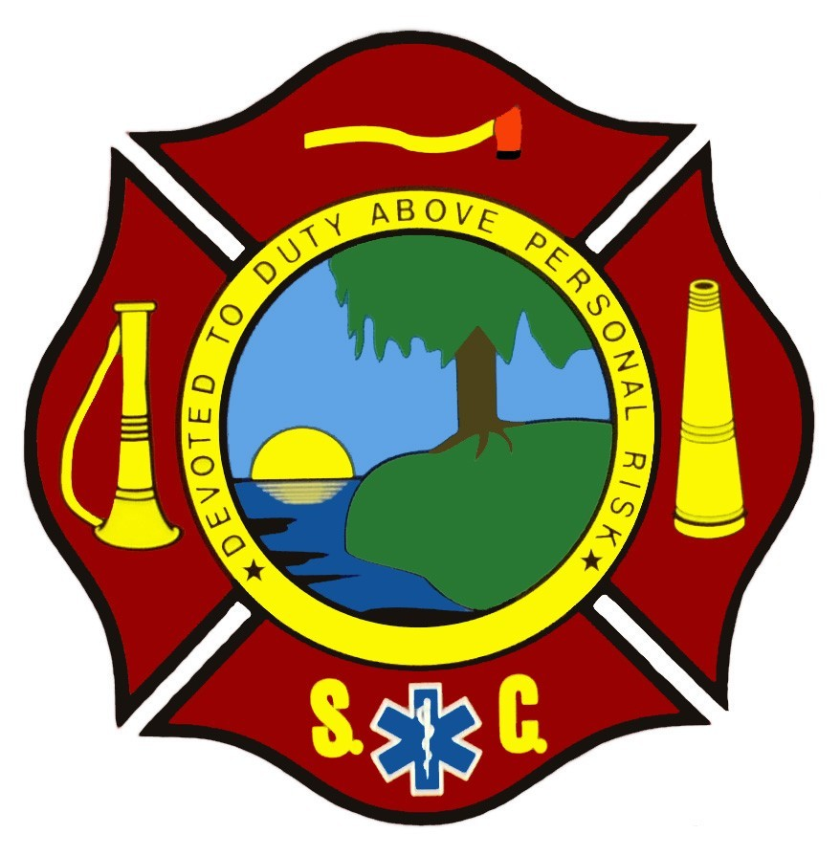
Complete copy of Ordinance is available at
www.blufftonfd.com or www.townofbluffton.com
Questions or complaints can be addressed by calling
(843) 757-1948

